Lab Exercise Report
Containerization and Cluster Orchestration
April 2026

Name: Kareem Ahmed Abdelhalim Roshdy
Group: SE3

1. Overview
This lab provided hands-on experience with containerization and cluster orchestration. Starting from Linux isolation primitives, we inspected namespaces and cgroups inside Docker containers, built and compared Docker images using basic and multi-stage builds, deployed a replicated application on a local Kubernetes cluster using kind, observed scheduling behavior using node labels and selectors, and tested self-healing by simulating pod and container failures.

2. Environment Setup
The lab was conducted on Windows 10 using Docker Desktop with WSL2 backend. The following tools were used:

Tool | Version | Purpose
Docker Desktop | Latest | Container runtime and image builder
kind | v0.23.0 | Local Kubernetes cluster inside Docker
kubectl | v1.30.0 | Kubernetes CLI for cluster management
ubuntu:22.04 | 22.04 LTS | Base image for namespace/cgroup experiments
python:3.12-slim | 3.12 | Base image for Flask application

3. Part A: Containers, Namespaces, and Cgroups

3.1 Task A1 — Namespace Isolation
An interactive Ubuntu 22.04 container was launched and inspected:
docker run --rm -it --name nsdemo ubuntu:22.04 bash
The following commands were run inside the container and their observations recorded:

Command | Output / Observation | Namespace
hostname | 0570426335cb (container ID) | UTS namespace — isolated hostname
ps -ef | Only 2 processes: bash (PID 1) and ps | PID namespace — isolated process tree
ip addr | command not found (tool not installed) | Network namespace — isolated network stack
mount | head | overlay filesystem on / (overlayfs layers) | Mount namespace — isolated filesystem view
cat /proc/1/cgroup | 0::/ (assigned to its own cgroup) | cgroup namespace — resource control

Key observation: The container had its own hostname, saw only its own processes starting from PID 1, and had an isolated overlay filesystem — all provided by Linux namespaces without any virtualization.
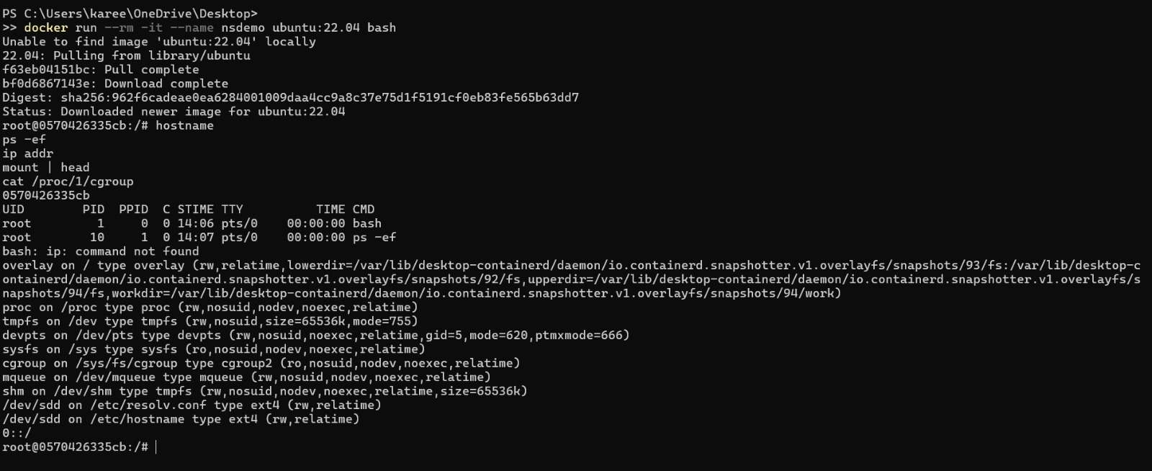

3.2 Task A2 — Host vs Container Process View
From the host, the container's real PID was obtained:
docker inspect nsdemo --format "{{.State.Pid}}"
Result: PID 1741. The host-side view was confirmed using docker top:
docker top nsdemo

View | PID | Explanation
Inside container | 1 | PID namespace makes bash appear as the first process
Host (docker top) | 1741 | Real Linux PID assigned by the host kernel

Key observation: The PID namespace gives the container its own process numbering starting at 1, while the host kernel sees the true PID (1741). The same process exists once but appears differently depending on which namespace view is used.

3.3 Task A3 — Resource Limits with cgroups
A resource-limited container was launched with CPU and memory caps:
docker run --rm -it --cpus="0.5" --memory="256m" ubuntu:22.04 bash
The stress tool was installed and run to generate maximum CPU and memory load:
stress --cpu 2 --vm 1 --vm-bytes 220M --timeout 30
Docker stats captured while stress was running:

Container | CPU % | Memory Usage / Limit | Observation
practical_heisenberg (limited) | 49.63% | 112.4MiB / 256MiB | CPU capped at 50%, memory ceiling enforced
nsdemo (unlimited) | 0.00% | 976KiB / 7.68GiB | Full host RAM available, no CPU limit

Key observation: Despite stress requesting 2 full CPU cores, cgroups enforced the 0.5 CPU limit, capping usage at 49.63%. The memory ceiling of 256MB was also enforced. This proves cgroups control resource consumption while namespaces control visibility.

4. Part B: Docker Image Layering

4.1 Application Files
A simple Flask application was created with two endpoints: / returning "Hello from Lab 3" and /health returning "ok". Dependencies were specified in requirements.txt with flask==3.0.0.

4.2 Basic vs Multi-Stage Image Comparison
Two Dockerfiles were created and built. The basic image installs dependencies directly in the final image. The multi-stage image uses a builder stage to install dependencies, then copies only the installed packages into a clean final image.

Aspect | lab3-basic | lab3-multi
Disk Usage | 199MB | 184MB
Content Size | 49MB | 44.7MB
Build stages | 1 stage | 2 stages (builder + final)
Build tools in final image | Yes (pip cache included) | No (stripped out)
Layer caching (app.py change only) | Re-runs pip install | Only copies app.py — pip layer cached
Security surface | Larger (more tools present) | Smaller (minimal final image)

Key observations: The multi-stage image is 15MB smaller in disk usage. More importantly, if only app.py changes, the multi-stage build reuses the cached pip install layer and only copies the new app.py — making rebuilds much faster. Layer order matters because Docker invalidates all layers after a changed layer, so dependencies should always be copied and installed before application code.
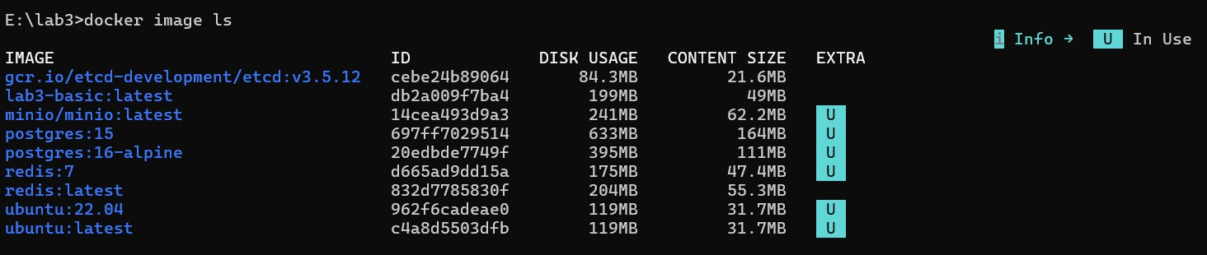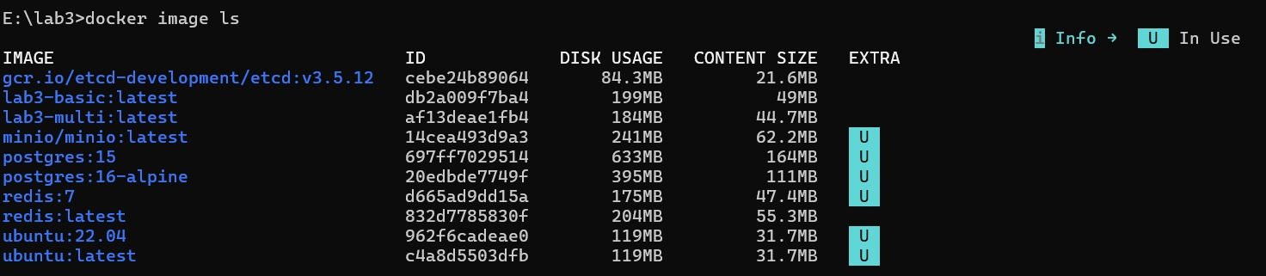

5. Part C: Local Kubernetes Orchestration with kind

5.1 Cluster Creation
A local Kubernetes cluster was created using kind:
kind create cluster --name lab3-cluster
The cluster started successfully with one control-plane node running Kubernetes v1.30.0 on Debian GNU/Linux 12 inside WSL2. Both Docker images were loaded into the cluster:
kind load docker-image lab3-basic --name lab3-cluster kind load docker-image lab3-multi --name lab3-cluster

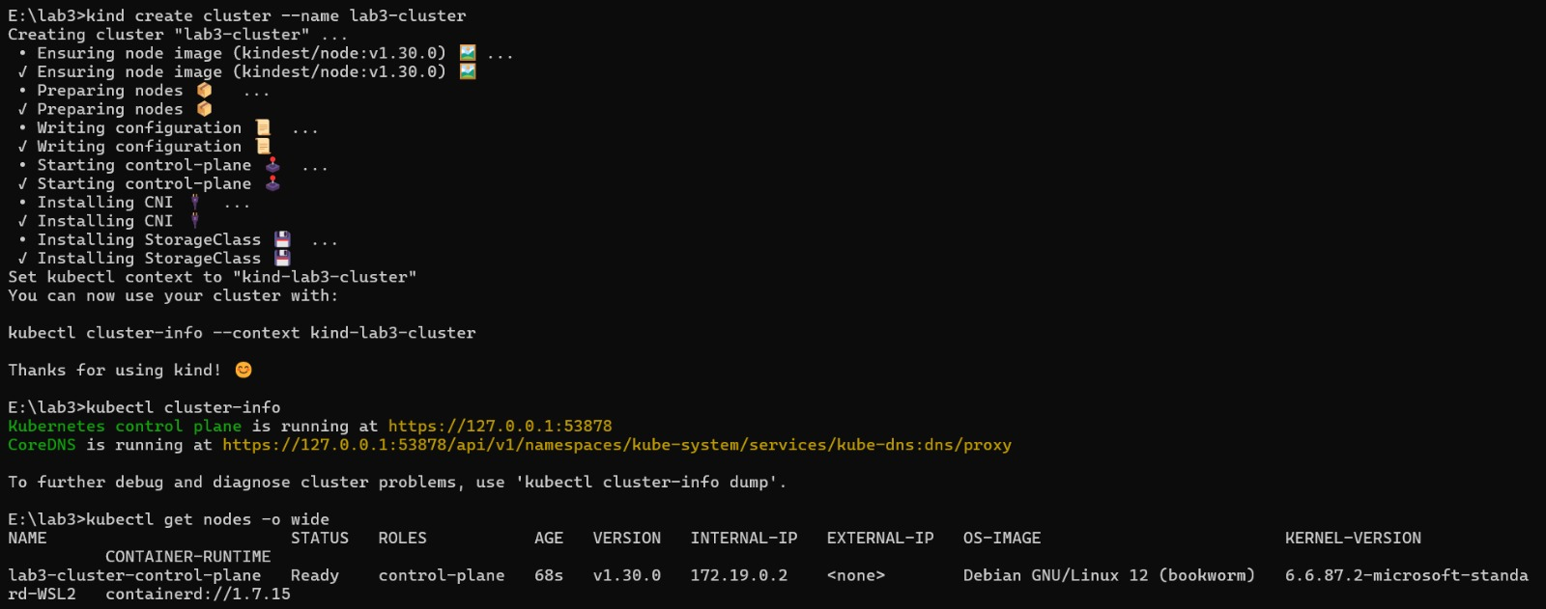

5.2 Deployment and Service
A Deployment with 3 replicas and a ClusterIP Service were created and applied. All 3 pods reached Running status:

Pod Name | Status | IP | Node
lab3-web-57cdbf4c4f-ctzzd | Running | 10.244.0.8 | lab3-cluster-control-plane
lab3-web-57cdbf4c4f-pfnd9 | Running | 10.244.0.10 | lab3-cluster-control-plane
lab3-web-57cdbf4c4f-vjn89 | Running | 10.244.0.9 | lab3-cluster-control-plane

5.3 Service Access
The service was accessed via port-forwarding. Both endpoints responded correctly: / returned "Hello from Lab 3" with HTTP 200, and /health returned "ok" with HTTP 200, confirming the Deployment, Service, and pod networking were all functioning correctly.
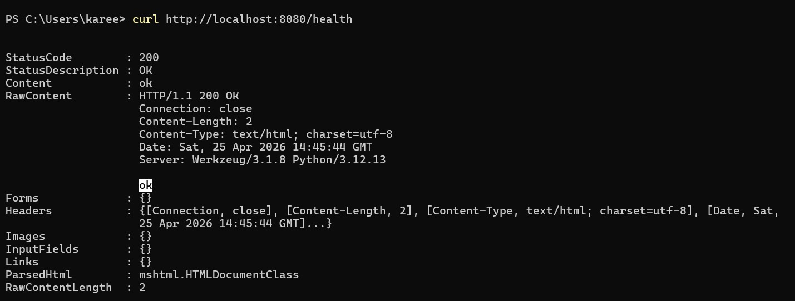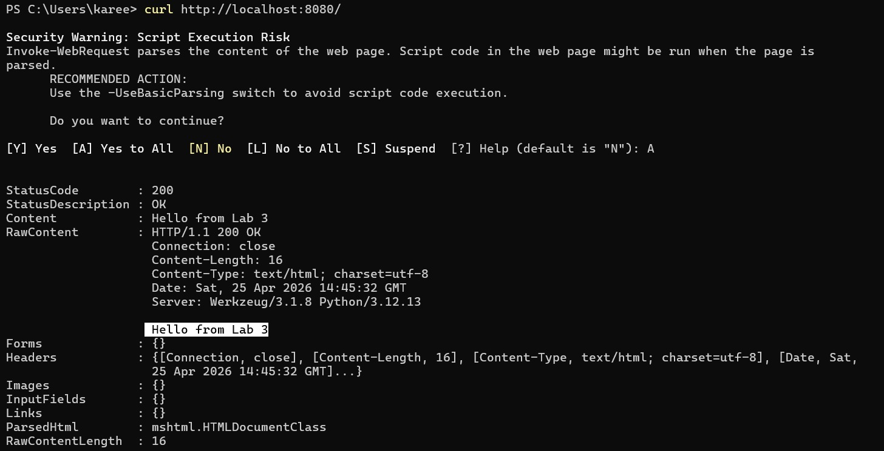

6. Part D: Scheduling and Placement

6.1 Node Labeling
The cluster node was labeled to enable selector-based scheduling:
kubectl label nodes --all node-role=general
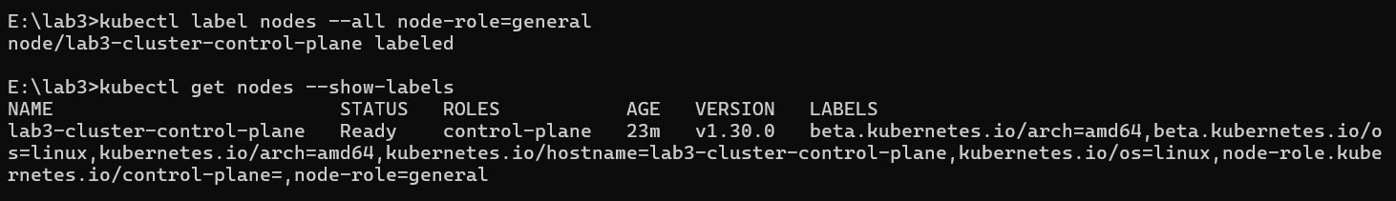

6.2 Node Selector Deployment
The deployment.yaml was updated to include a nodeSelector requiring node-role=general. After re-applying, all 3 pods were scheduled only on the labeled node (lab3-cluster-control-plane).

Reflection: Declarative scheduling with node selectors is fundamentally different from hard-coding machine names in traditional deployments. With declarative scheduling, operators express constraints rather than specific targets. If a node fails, Kubernetes can reschedule pods on any other node that matches the label — improving resilience. Hard-coded machine names create brittle deployments that require manual updates when infrastructure changes.

7. Part E: Self-Healing and Health Probes

7.1 Task E1 — Pod Deletion and Automatic Recovery
One pod was deleted to trigger self-healing:
kubectl delete pod lab3-web-85cf8c9c57-852dh

Pod | Action | AGE after recovery | Observation
852dh | Deleted | Gone | Removed from cluster
rb87t | Auto-created | 71s (vs 6m+ for others) | Brand new pod with new name

Why reconciliation, not restart: Kubernetes uses a reconciliation loop — the Deployment controller constantly compares desired state (3 replicas) with actual state. When a pod is deleted, the controller detects the mismatch and creates a new pod to restore the desired count. This is different from a simple restart because the controller does not remember the deleted pod — it simply sees that the current count is below desired and acts accordingly.
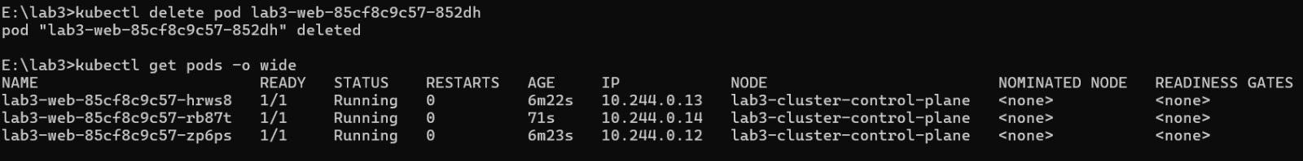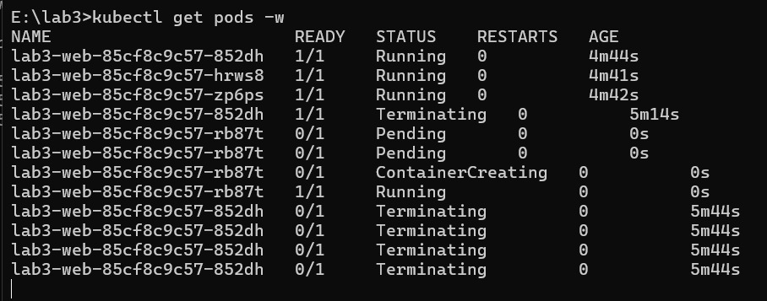

7.2 Task E2 — Health Probes
A new deployment with readiness and liveness probes was applied. Both probe pods started successfully.

Probe Type | Path | Initial Delay | Period | Purpose
Readiness | /health | 3 seconds | 5 seconds | Controls when pod receives traffic
Liveness | /health | 10 seconds | 10 seconds | Controls when container is restarted

Why probes are not interchangeable: A readiness probe failure removes the pod from the Service load balancer but does not restart the container — useful when the app is temporarily busy. A liveness probe failure restarts the container — useful when the app is deadlocked. Using liveness where readiness is needed would cause unnecessary restarts during normal startup delays.
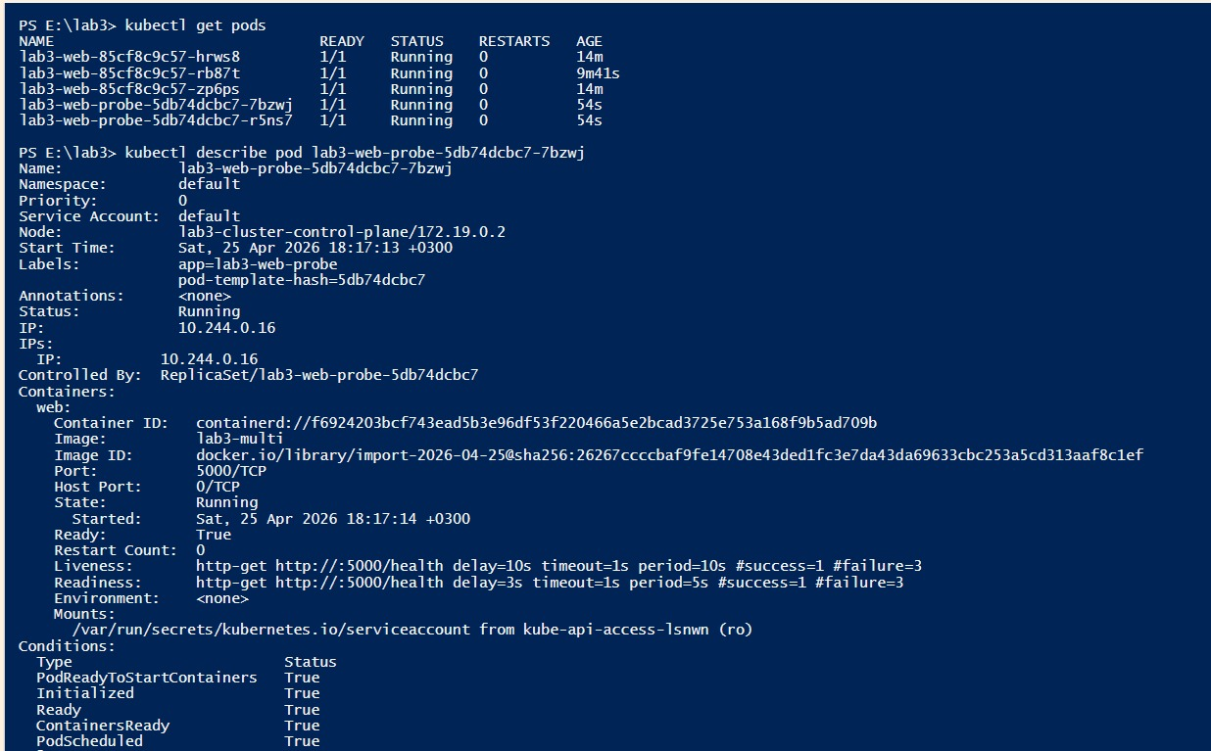
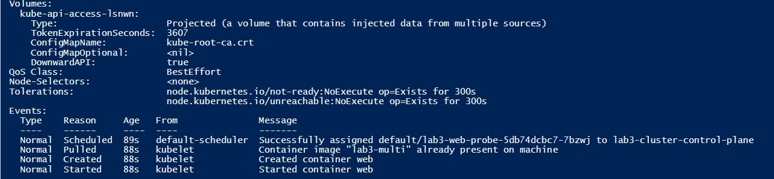

7.3 Task E3 — Pod Replacement Observation
A probe pod was force deleted to observe the replacement behavior. The following sequence was observed in kubectl get pods -w:

Event | Pod Name | Status | Observation
1 | r5ns7 | Terminating | Deleted pod begins graceful shutdown
2 | tfqts (new) | Pending | Deployment controller creates replacement immediately
3 | tfqts (new) | ContainerCreating | Container image being started
4 | tfqts (new) | 0/1 Running | Container running but readiness probe not yet passed
5 | tfqts (new) | 1/1 Running | Readiness probe passed after 6 seconds

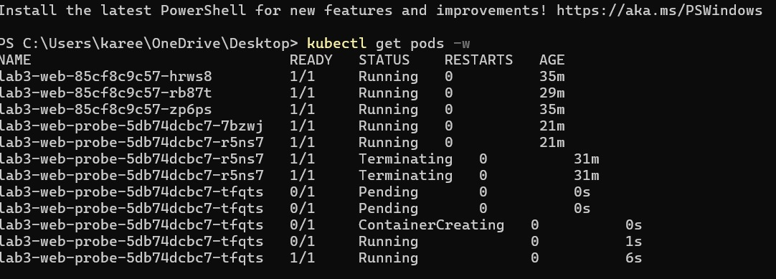

8. Reflection Questions
Why do namespaces alone not guarantee fair resource use? Namespaces isolate what a process can see but do not limit how much of a shared resource it consumes. Without cgroups, a container could use all available CPU or memory and starve other containers running on the same host.

How do cgroups improve cluster stability? cgroups enforce hard limits on CPU, memory, and I/O per container. This prevents any single container from monopolizing host resources, ensuring other workloads remain unaffected and the cluster remains stable even under heavy load.

Why is Docker image layering important for large-scale orchestration? Layers are cached and shared across images. In a cluster with hundreds of nodes pulling images, shared base layers (like python:3.12-slim) are downloaded once and reused. This dramatically reduces bandwidth, storage, and deployment time at scale.

What does Kubernetes mean by desired state? Desired state is a declaration of what the system should look like — for example, 3 replicas of this pod running. Kubernetes continuously compares desired state with actual state and takes action to reconcile any differences, without manual intervention.

How is self-healing different from traditional manual operations? In traditional operations, a failed server requires human detection, diagnosis, and manual restart or replacement. Kubernetes self-healing is automatic and continuous — the reconciliation loop detects failures within seconds and restores desired state without any human involvement.

Why are readiness and liveness probes not interchangeable? Readiness controls traffic routing while liveness controls container lifecycle. Confusing them causes either unnecessary restarts or undetected deadlocks.

What is one limitation of a single-node kind cluster for scheduling observations? With only one node, all pods are always placed on the same node regardless of scheduling policies. In a real multi-node cluster, the scheduler would distribute pods across nodes for resilience, and node selectors and affinity rules would produce observable placement differences.

9. Conclusion
This lab demonstrated the full stack of modern container orchestration — from the Linux kernel primitives (namespaces and cgroups) that make containers possible, through Docker image layering that makes them efficient, to Kubernetes orchestration that makes them resilient at scale. The practical experiments showed that containers are not magic but rather ordinary Linux processes with carefully applied isolation and resource controls. Kubernetes builds on this foundation to provide declarative, self-healing cluster management that eliminates the manual toil of traditional operations.

